**A000-Mex-Colima-Tlaloc-Incensario-Ceramic 200 BCE**

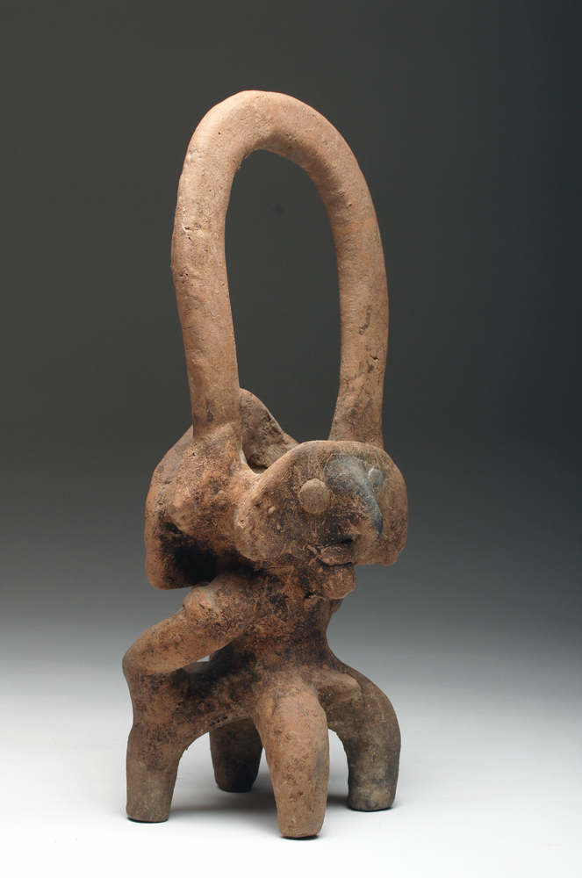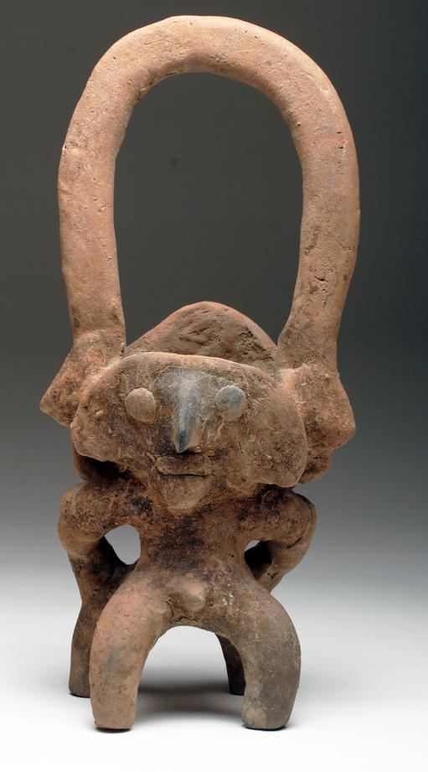

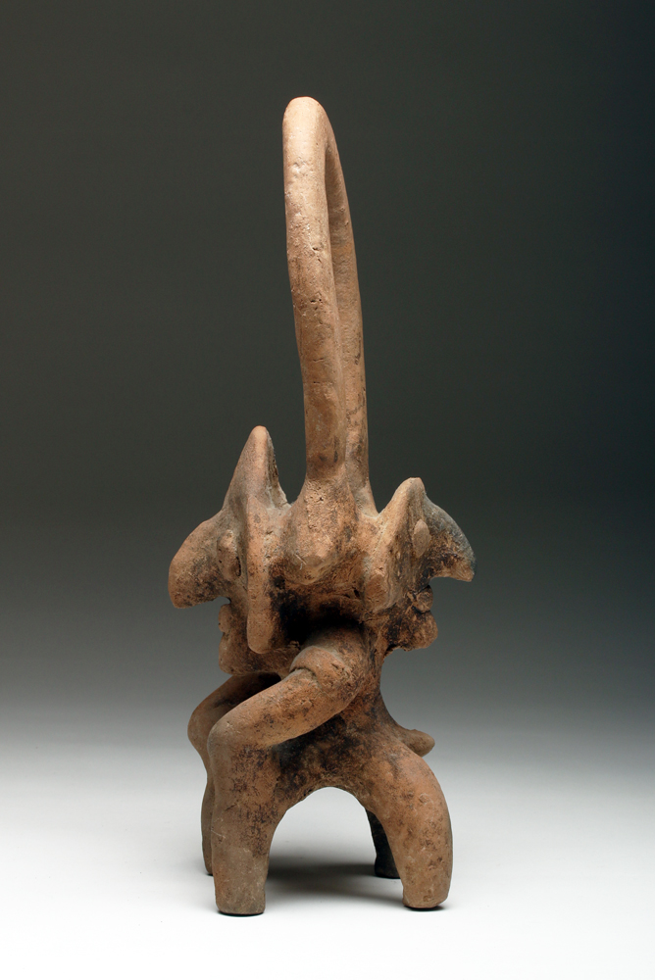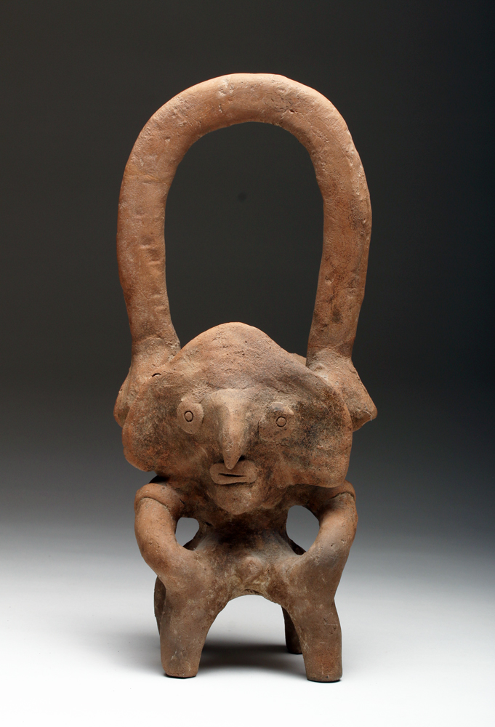

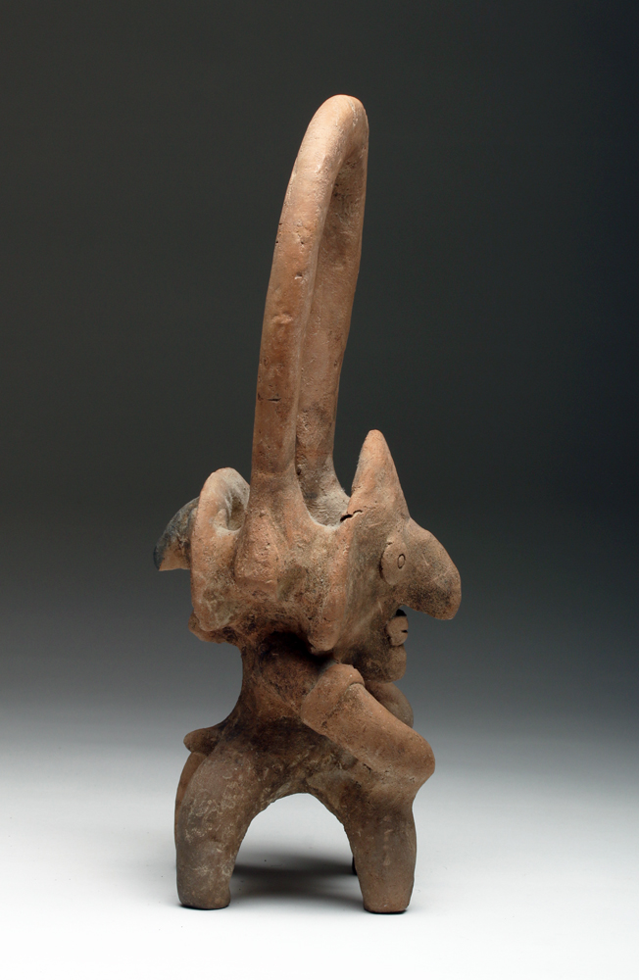

**Mex-Colima-Tlaloc-Incensario-Ceramic 200 BCE**

Case No.: 9

**Accession No.**

**Formal Label: Mex-Colima-Tlaloc-Incensario-Ceramic 200 BCE**

**Display Description:**

**Pre-Columbian, West Coast, Mexico, Ca 200 BCE. Large pottery incensario featuring Tlaloc. Each side features the god, seated in the nude with prominent genitals and applied semi abstract facial features; large looping handle.**

* **LC Classification: F1219.1.C75**

**Date or Time Horizon:**

**Geographical Area:**

**Map:**

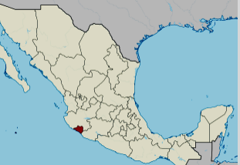

**Location of Colima, Mexico. https://upload.wikimedia.org/wikipedia/commons/thumb/a/a6/Colima_in_Mexico_%28location_map_scheme%29.svg/375px-Colima_in_Mexico_%28location_map_scheme%29.svg.png**

**GPS coordinates:** [19°10′N 103°53′W](https://tools.wmflabs.org/geohack/geohack.php?pagename=Colima&params=19_10_N_103_53_W_type:adm1st_region:MX)

**Cultural Affiliation:**

**Media: ceramic, kaolin.**

**Dimensions: 14" H**

**Weight:**

**Condition: A few invisible repairs to handle, encrusted surface**

**Provenance:** Originally deposited in a shaft tomb. Recovered from the ancient Colima culture in Western Mexico prior to 1970.

**Discussion:**

The Los Ortices period (500-300 BCE) established elements of the Colima culture, including shaft tombs and a distinctive ceramic style called *rojo bruñido,* or burnished red. The following Comala or Colima culture developed at the Comala site (300-300 CE). The Colima people perfected burnished red pottery *rojo bruñido* and produced terra cotta figurines of people and animals with distinctive fluid lines. The Comala site shows influence from Teotihuacan. Around 500 CE, another site in Armería developed along the river of the same name.

**References:**

Reynolds, Richard D. 1993. *The Ancient Art of Colima, Mexico*. Walnut Creek, Calif.: Squibob Press.

# Order details

## Sales order

Sold by [artemisgallery](http://myworld.ebay.com/artemisgallery) ( [637](http://feedback.ebay.com/ws/eBayISAPI.dll?ViewFeedback&userid=artemisgallery) )

### Delivery package 1 of 1

Estimated delivery Tuesday, Feb 2, 2016

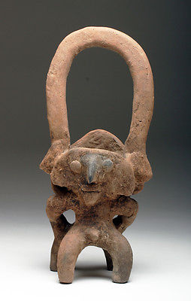

#### [Colima Incensario in Form of Tlaloc](http://www.ebay.com/itm/381258126822)

|  |  |
| --- | --- |
| Item price | $595.00 |
| Quantity | 1 |
| Item number | 381258126822 |
| Shipping service | UPS Ground |

## Shipping address

Ralph J Coffman Jr

149 Atlantic Ave

Swampscott MA 01907-2427

United States

## Order total

|  |  |
| --- | --- |
| Subtotal | $595.00 |
| Shipping | $44.99 |

**Total**

$639.99

Order placed on

Monday, Jan 25, 2016

Payment method

PayPal

Payment date